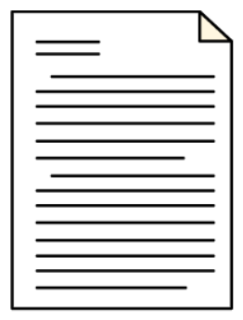

**JFM Fund Plan 2024-27**

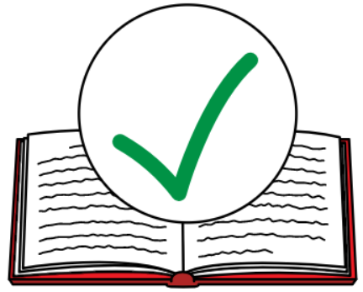**Easy English**

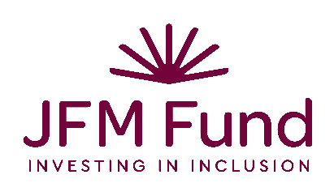**Who we are**

We are the JFM Fund. We give money to do good for people with disabilities.

Our values are to make sure people with disabilities

* 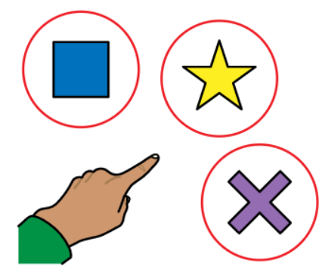live good lives
* have choice and control
* have good roles in the community
* are supported to improve their skills and abilities.

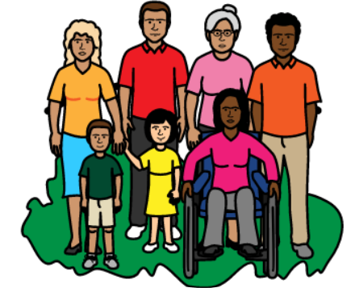Our purpose is to make sure people with disabilities are

* included in all communities
* have valued roles in the community.

Our mission is to

* improve policies and practices that affect people with disabilities
* use funding well so it can help people with disabilities
* 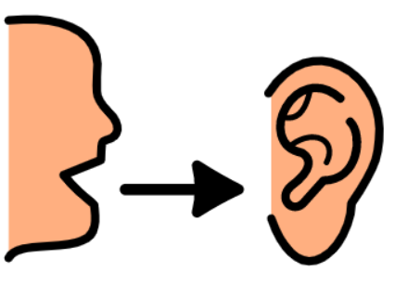listen to what people with disabilities want.

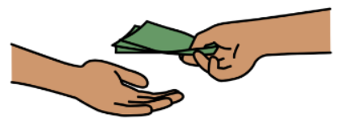We give money to help people with disabilities. This is called a **grant.**

We have a $1m grant program that improves

* policies
* 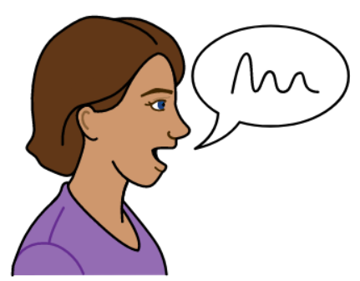advocacy (speaking up for the rights of people with disability)
* disability inclusion.

People with disability will be involved in running the grant program. We want to hear what people with disabilities have to say.

We want people with disabilities to be leaders. We will help them to build these skills.



Our grants will improve how other organisations are run as well.